Proposal by:
25M-0547 M. Usman Saleem
25M-3001 Ahmad Abdullah
25M-0536 Reeja Sohail

Gold Fitness gym

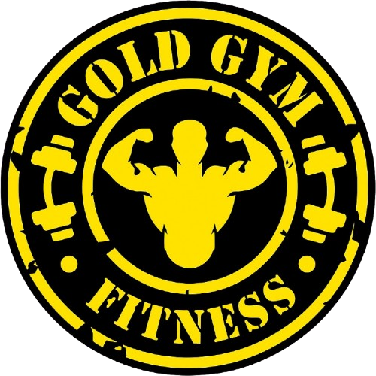

Project idea & description  Our idea is to create website for a gym business named “Gold Fitness Gym”. This website will contain critical information needed by the muscle bros before joining our gym. We will allow the users to thoroughly research our gym business before committing to us. |  | Key features  - Business information: We will provide necessary information on the website.  - Attractive: Our website will have attractive design and color scheme.  - Easy to navigate: We will provide hyperlinks on the website so user can navigate easily throughout the page.  - Contact Page: We will provide contact information to the user so he can communicate with the business through email or socials.

Promotional poster
